**Education Info – Project Details**

**Purpose Of Project:**

The Main Purpose of This Application Is Students are find the college and university easily.

In This Application, User (Admin) Can Handle The System. Such As:

The Admin Can Insert the Details Of Any college & university.

Also, Can Modify And Delete All The Details Of university and colleges.

Handling & Maintaining Of university and colleges Information Becomes easy.

**Objective:**

The Objective Of This Project Is, the student can chouse the college and university as

par choice. very easy to find nearest college and university in his state and city.

To Store The Information Of The college and university And Manage Them.

To Reduce The Processing Time, And Acquire More Accurate Information.

To Make The System Interface More User-Friendly.

**Scope Of The Project:**

This Project Will Be Useful For Any Student. So The Scope Of The Project Is Generation.

There Will Be No Running Cost, And This System Is General Application Which Means

Any Institute Can Use It Easily, That Defines It’s Scope For Lifetime.

▪ This Application Is Divided Into Several Categories:

1. Login

2. Registration

**Code:**

**Google Drive Link for Code (Zip File):**

[**https://drive.google.com/drive/folders/1z5rnwpp1453HyzFwRhfEKHYORYZ7iWys?usp=share_link**](https://drive.google.com/drive/folders/1z5rnwpp1453HyzFwRhfEKHYORYZ7iWys?usp=share_link)

**Design Screenshots:**

**Front Page: Home Page:**

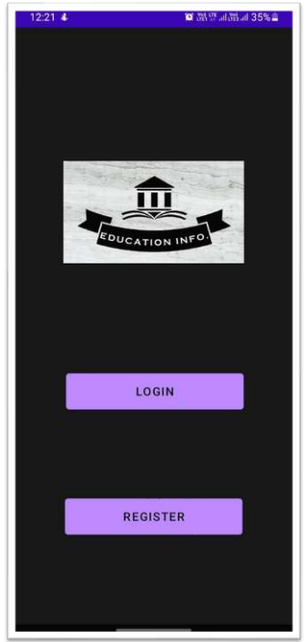 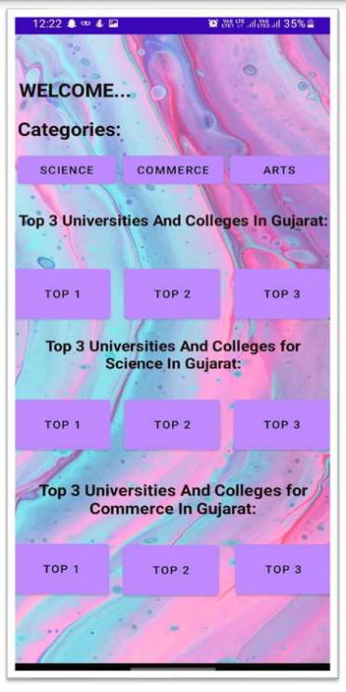

**Output Screenshots:**

**Output-1: Output-2:**

